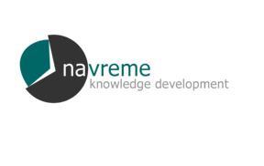
Ss. Cyril and Methodius University (Ukim)

Workshop 1 on
”Support for Quality Assurance and Evaluation Methods”

QA - Workshop Agenda

Thursday, 29 May 2003 – Goals and Achievements of National QA System

12:00-12:15 Welcome and Introductions (VC, JF, CS)
12:15-12:30 Presentation of the Workshop Agenda (CS)
12:30-13:00 Overview on Macedonian QA Programs and Arrangements: State of the Art (V.C)
13:00-13:30 Questions for Clarification (navreme team) and General Discussion:
The QA Scheme and its Implementation in Maceedonia

13:30-14:00 Coffee break

14:00-14:30 Preliminary Comments and Observations on the Above, based on Navreme written statement (JF)
14:30-15:00 Q&A -- Open discussion
15:00-15:15 Convergence and Divergence: The Macedonian QA Scheme in the Light of International Experience (BB)

Friday, 30 May 2003 – Objectives for the New QA Project

09:00-09:15 Summary Day 1, Outlook Day 2 (CS)
09.15-09:45 Working Groups: Current Needs in QA
09.45-10.15 Presentation and Analysis of Working Group Results (Clustering)
10:15-10:30 Defining Priorities

10.30-10.45 Coffee/Tea Break

10.45-11.15 Working Groups: What are Realistic Objectives for an International QA Project?
11.15-11.45 Presentation and Analysis of Working Group Results (Clustering)
11.45-12:00 Defining of Priorities and Criteria
12:00-12.15 Conclusions: Action Plan (Next Steps; Tasks, Roles and Responsibilities)

12.15 Lunch

